DANA ILMU PENGETAHUAN INDONESIA (DIPI)
Indonesia, April – Juni 2016

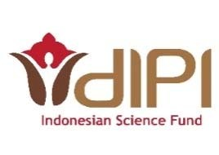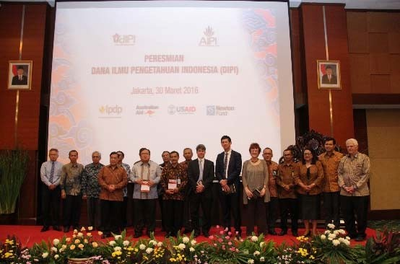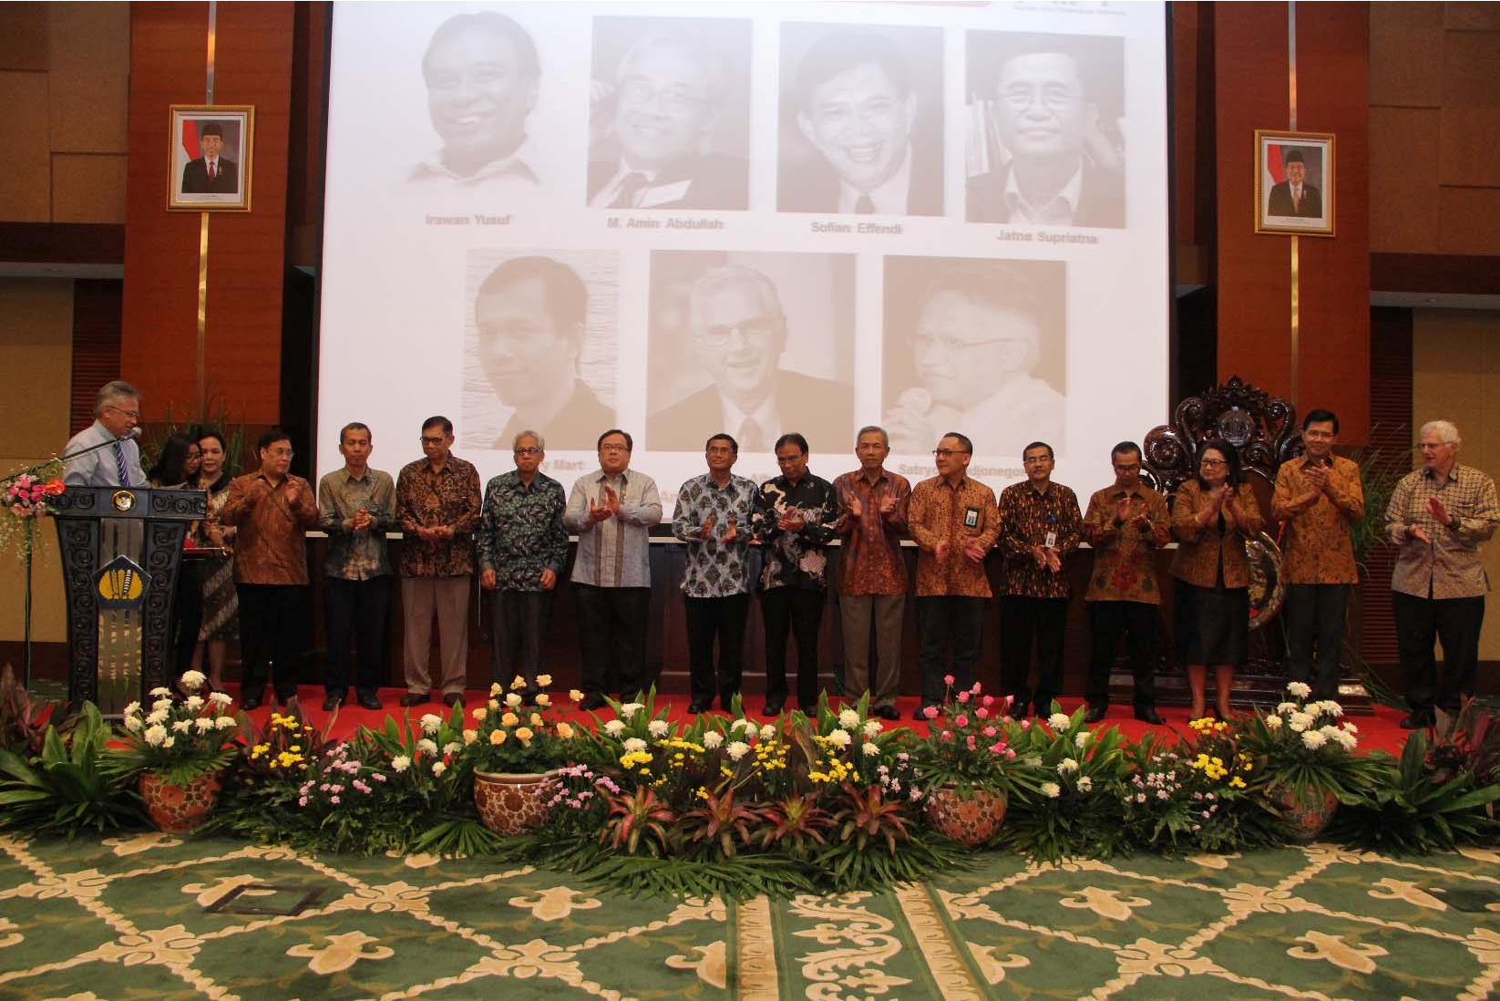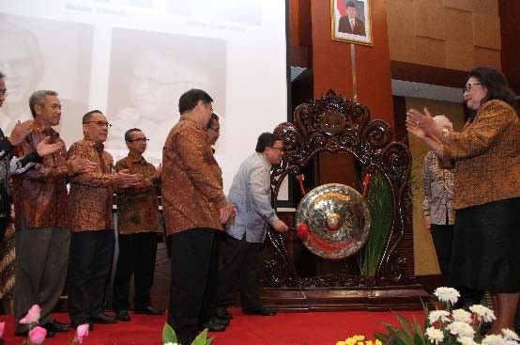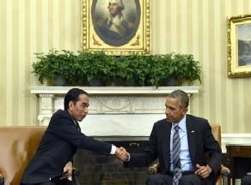
www.dipi.id
Dana Ilmu Pengetahuan Indonesia (DIPI)
Jl. Medan Merdeka Selatan No. 11, Jakarta Pusat 10110
Autonomous, independent body

Under the auspices of the Indonesian Academy of Sciences (AIPI)

AIPI GENERAL ASSEMBLY

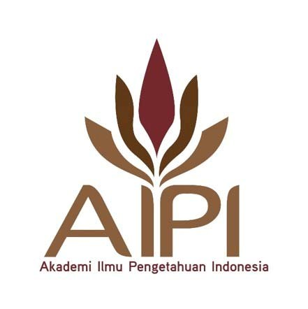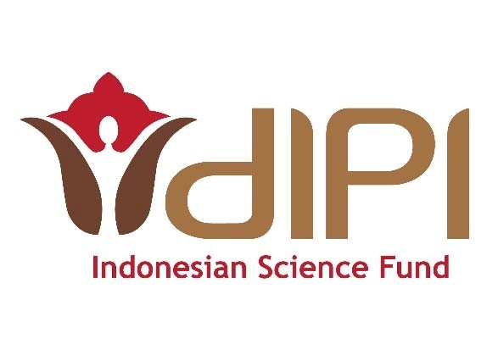

LAW NO. 8/1990 REGARDING AIPI PRESIDENT DECREE NO. 9/2016 REGARDING AIPI BYLAWS & CONSTITUTION
MILESTONES
MAY 27, 2015

OCT 13, 2015

FEB 29, 2016
JUL 10, 2012

AUG 7, 2015

OCT 26, 2015
MAR 30, 2016

LAUNCHING OF CONSULTATION DRAFT The need for establishing DIPI, Dana Ilmu Pengetahuan Indonesia, was proposed in the report on Creating an Indonesian Science Fund,
a collaboration between
AIPI, World Bank, and
Australian Aid

AIPI-LPDP MOU AIPI and LPDP signed MoU to provide initial funding for DIPI.

INDO-US JOINT STATEMENT Indonesia and United States to strengthen scientific cooperation, Indonesian Science Fund headlines the purpose

ANNOUNCING DIPI AIPI launched DIPI, the country’s first research funding institution that provides multi-year grants for fundamental and frontier research.

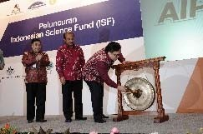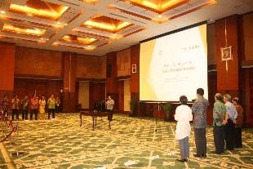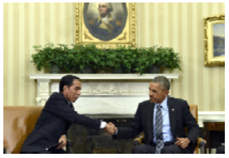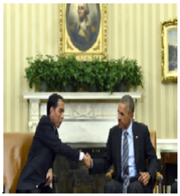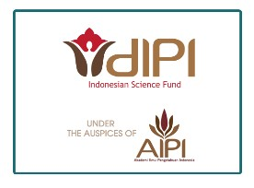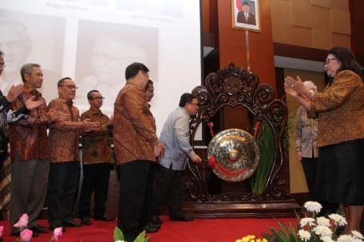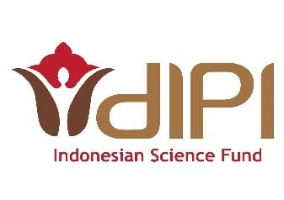

SOFT LAUNCHING AIPI launched the initiative to establish the Indonesian Science Fund as an independent body under its auspices

AIPI GENERAL ASSEMBLY Approval for the establishment of DIPI
PRESIDENT’S DECREE Keppres No.9/2016) was signed on February 29th 2016, much to the anticipation as it includes the legal basis to establish Indonesian Science Fund, among others.
MISSION
Enable more productive fundamental and frontier research

More publications and patents, more productive scientific effort in all areas, and ultimately in more innovation, more science-based enterprises.

Increase the pool of trained research scientists

An enlarged community of trained scientists to encourage innovation and to create science-based enterprises. The availability of research support can encourage good researchers to remain competitive and promote a culture of scientific excellence.

DIPI 2016 Research Call

Focus Areas:
• Life, Health, and Nutrition
• Identity, Diversity, and Culture

Important Dates:
• Online submission deadline: July 31, 2016

DIPI will provide research grant up to 3 years and Rp 1.5b/year

Call details & grant manual: www.dipi.id/en/dipi2016/

Contact: 2016@dipi.id

How to Apply: apply.dipi.id
DIPI-MRC Joint Health Research
Call on Infectious Diseases

Important Dates:
• Deadline for Expression of Interest: June 15, 2016 to international@headoffice.mrc.ac.uk
• Call’s Deadline: July 14, 2016

This initiative will provide funding for high quality 2 year collaborative research projects focusing on infectious diseases of relevance to Indonesia.

Priorities:
Dengue, dengue-like illness and other vector-borne diseases, Malaria, Avian Influenza, Hepatitis, Tuberculosis

Call details: www.dipi.id/en/dipi-mrc/
DIPI-RCUK Research Call for
Proposals in Astronomy

Important Dates:
• Call deadline: 22:00 WIB, Tuesday, 02 August 2016

This initiative will provide funding for flexible short-term support for high-quality, collaborative research which address the following topics:
• Capacity Building in Big Data and Technology Development
through Astronomy
• Skills for using Large Facilities

Call details: http://www.dipi.id/en/dipi-rcuk-astronomy/
DIPI Organizational Structure

AIPI General Assembly

Executive
Director (ED)
Board of
Advisors
Board of
Benefactors

Deputy ED
Science Steering Board (DPI)
DPI Secretariat

for
Grant Management
Deputy ED
For Operations / Chief of
Staff
Deputy ED for
Resource Mobilization

Director
Director
HR Director
Director
& Director
Team :
Outreach
Program | Mon-Ev | Finance & | Procurement | Communication | Legal | Resource Mobilization

Director
Private & Foundations
Bilateral & Multilateral

Grant
Officer(s)
Office
Manager
Internal
Audit
IT Manager
Outreach
Officer(s)
Media & Content Officer(s)

Fiscal
Agent(s)
Procurement
Agent(s)

UK-Indonesia Joint Health Research Call on
Infectious Diseases

Connect with us

www.dipi.id
info@dipi.id general inquiries
2016@dipi.id inquiries on DIPI 2016 Research
Call

Dana Ilmu Pengetahuan Indonesia

@dipi_indonesia

