Paphiopedilum Flowering Induction with Light Intensity and Growth Regulator Substance

Dahlia 1, a)

1 Department of Biology, Faculty of Mathematics and Natural Science
State University of Malang, Indonesia

a) dahlia_bio@ um.ac.id

Abstract. This research has conducted for searching appropriate light intensity and growth regulator substance concentration to induce flowering on Paphiopedilum. The result showed that Paphiopedilum praestans treated by light intensity 60%, growmore and GA 0.5 mg/l is the earliest flowering. The length of the flower stalks on Paphiopedilum praestans treated by light intensity 60%, growmore and GA dose 0.5 mg/l is the longest stalks. The petals number of flowers per stalk on Paphiopedilum praestans treated with light intensity 60%, liquinox bloom and AIA 0.5 mg/l is the largest number of flower petals and the earliest flower blooming. On the Orchid Paphiopedilum praestans treated by light intensity 30%, liquinox bloom and AIA 0.5 mg/l is 105 days faster. Increasing number of the Paphiopedilum praestans leaves treated by light intensity 60%, growmore and GA dose 0.5 mg/l is more plentiful than Paphiopedilum glaucophyllum and Paphiopedilum mastersianum.

Keywords: Paphiopedilum mastersianum, Paphiopedilum praestans, Paphiopedilum glaucophyllum, growth regulator substance, light intensity, liquinox bloom, growmore, GA, IAA

INTRODUCTION

Orchid is one of popular flowers that it have many admirers, it have various colors, shapes, sizes and motifs. Orchids belong to Orchidaceae. Orchids are ornamental plant that have high aesthetic value and also have importance role in flower trading [1]. The orchid industries in Indonesia are still lag from other countries, such as Thailand, Taiwan, Singapore, and Australia. This case is caused by limitation of flower pots availability and eminent orchid cultivars in market [15].

Orchids’ growth both vegetative and generative is determined not only determined by genetic factors, but also by climate factors and maintenance factors [5]. Paphiopedilum are stated that can grow well on altitudes of 50-600 m above sea level, temperatures range between 15-35 ° C (optimum, 21 ° C), humidity (RH) and climate specifications between 65-70%, and semi shade ranges from 15-30% of sun light intensity.According to our previous study, allotment of light intensity between 65-100% leads moth orchid leaves burning and sprouten even death. However, light intensity treatment with less than 30% moth leaves run into vegetative growth, colored dark leaves and susceptible from disease. From that result we concluded that light intensity between 30-60% was appropriate for moth orchid’s growth [2]. External factors affect the intensity of sunlight, temperature, humidity, air, fertilizer needs, as well as the place and the media grow accordingly, air circulation, repotting, pest and plant disease. Growth increment and accelerating Orchids flowering both quality and quantity needs to be supported, this can be worked by giving growth regulator substance such as auxin, ethylene, giberellin, cytokinin, absisin, inhibitor
and other. Auxin allotment for plant growth and development increases the nucleic acid content in cells and it leads synthesis of protein nucleic acid faster [3]

Cytokinin is growth substance triggered both growth and morphological tissue. Cytokinin play role in cells formation, cells division and enlargement [4]. Granting of gibberellin increases plant growth. Defoliation of orchid leaves is assumed by unbalancing growth regulator substance. Each growth regulatory substance has different effect on plant growth, cytokinin and auxin are used for vegetative growth, while gibberellin is used for generative growth. From this case, we used auxin and giberrelin as growth regulator substance and growmore and liquinox bloom as chemical fertilizer substitute. This result was conducted for observing the effect of light intensity and growth regulator substance on Paphiopedilum flowering.

MATERIALS AND METHOD Materials
This research used Paphiopedilum that it have 2-3 leaves, fertilizer containing growmore and liquinox bloom,
growth regulator substance containing auxin, and gibberellin, and pesticide. The instrument used such as plastic pots
with Ǿ15 cm, technical scales, hand sprayer, and plastic tray.

Method

This research uses Factorial Completely Randomized Design as design of Experiment, we did 3 treatments and 6 repetitions. Factor I: treating sun light (C1: 60% light intensity and C2: 30% light intensity), factor II: growth regulator substance: gibberellin and auxin with each substance containing dose 0.5 mg/l, factor III: fertilizer containing growmore and liquinox bloom with each substance containing dose 0.5 mg/l. This study used a randomized complete design (RCD) factorial pattern, with 3 levels and 6 times the treatment of Deuteronomy. Factor 1: i.e. awarding rays of light intensity (C1 and C2 light intensity 60 30), ZPT as a factor 2 is: GA; AIA and with each dose of 0.5-2 mgl,. Factor 3: Fertilizer: liquinox bloom and each with a dose of growmore 0.5 mgl, and control. Plants with 2-3 leaves sprayed fungicide solution of 0.2, then put on the shelf and left on for one week.

RESULTS

According to analyze result, growth and flowering parameter is state in following tables.

TABLE 1. The average of high increment (cm) on three various locals of Phapiopedilum species after treating
with light and growth regulator substance.
Varieties, luminous intensity and
Growing Regulatory Substances The Orchid Paphiopedilum Cultivars
Paphiopedilum
Paphiopedilum
Paphiopedilum
glaucophyllum praestans mastersianum

Light 60% growmore and GA dose 0.5 mg/l | 13d |  | 20c |  | 15c
Light 60 liquinox bloom and AIA 0.5 mg/l  Light 30% growmore and GA dose 0.5 mg/l  Light 30% liquinox bloom and AIA 0.5 mg/l | 10b  11c  8a |  | 16b  15b  13a |  | 12b  13b  10c
Explanation: the alphabet in same treatment column show insignificance different according Duncan test at level
α5%

The analysis result of the high increment was shown in Table 1. Paphiopedillum after treating with light 60% growmore and GA dose 0.5 mg/l had 20c notation, it was higher than Paphiopedilum glaucophyllum 13d and Paphiopedilum mastersianum 15c. The high increment of Paphiopedilum praestans was about 1.3 (20/15=1.3) higher than Paphiopedilum mastersianum and 1.5 (20/13=1.5) higher than Paphiopedilum glaucophyllum.
From the comparison of orchid high increment, we know that the high increment of Paphiopedilum praestans
is about 1.28 times higher, Paphiopedilum praestans is about 1.5 times higher, and Paphiopedilum praestans is
1.17 times higher. 20/16=1.25c with AIA and liquinox, 16b, 15b, 13a.

TABLE 2. The average of leaves number increment on three on three various locals of Phapiopedilum species after treating with light and growth regulator substance.

Varieties, luminous intensity and Growing
Regulatory Substances The Orchid Paphiopedilum Cultivars
Paphiopedilum
Paphiopedilum
Paphiopedilum
glaucophyllum praestanss mastersianum

Light 60% growmore and GA dose 0.5 mg/l | 5c |  | 8c |  | 6c
Light 60% liquinox bloom and AIA 0.5 mg/l | 4ab |  | 6b |  | 5b
Light 30% growmore and GA dose 0.5 mg/l | 4ab |  | 6b |  | 5b
Light 30% liquinox bloom and AIA 0.5 mg/l, | 3a |  | 3a |  | 3a
Explanation: the alphabet in same treatment column show insignificance different according Duncan test at level
α5%

The statistical analysis for leaves number increment was shown in Table 2. It shown that Paphiopedilum praestans after treating with light intensity 60%, growmore and GA dose 0.5 mg/l had 8c leaves number, the amount was more plentiful than Paphiopedilum glaucophyllum and Paphiopedilum mastersianum, 5 c and 6 c.

Cultivars Paphiopedilum praestans after treating with light intensity 60%, growmore and GA dose 0.5 mg/l was obtained difference leaves increment about 2 leaves. Treating with light intensity 30%, growmore and GA dose 0.5 mg/l had difference 2 leaves number increment, it was more plentiful than Paphiopedilum glaucophyllum and Paphiopedilum mastersianum that had just difference 1 leaf increment.

The comparison of leaves number increment on three cultivars had 1.67 times more plentiful than others that had 1.33. Paphiopedilum praestans and Paphiopedilum mastersianum had 1.50 times more plantiful

TABLE 3. The average of rod diameter increment on three various locals of Phapiopedilum species after treating with light and growth regulator substance.

Varieties, luminous intensity and Growing
The Orchid Paphiopedilum Cultivars
Regulatory Substances
Paphiopedilum
Paphiopedilum
Paphiopedilum
glaucophyllum praestans masterisianum

Light 60% growmore and GA dose 0.5 mg/l | 0.66d |  | 0.91d |  | 0.77d
Light 60 % liquinox bloom and AIA 0.5 mg/l | 0.62c |  | 0.78b |  | 0.72c
Light 30 growmore and GA dose 0.5 mg/l | 0.56b |  | 0.76c |  | 0.64b
Light 30% liquinox bloom and AIA 0.5 mg/l, | 0.46a |  | 0.68a |  | 0.47a
Explanation: the alphabet in same treatment column show insignificance different according Duncan test at level
α5%

The average of rod diameter increment was shown in the table 3. It showed that cultivar Paphiopedilum praestans treating with light intensity 60%, growmore and GA dose 0.5 mg/l had 9.1 cm diameter increment, it was more longer than Paphiopedilum mastersianum and Paphiopedilum glaucophyllum.
Paphiopedilum praestans treating with light 60%, growmore and GA dose 0.5 mg/l was obtained difference
diameter incresment as long as 25. However, treating light intensity 30%, growmore, and GA dose 0.5 mg/l was obtained difference diameter increment as long as 14 if compared with Paphiopedilum glaucophyllum and Paphiopedilum mastersianum. Trating light intensity 60%, growmore and GA dose 0.5 mg/l 20 was 1.21 times longer than 1.24 times. The comparison of rod diameter increment 1.44 times longer. The comparison of rod
diameter increment on all three cultivars 1.67 times longer. Others had 1.33 times longer. Paphiopedilum glaucophyllum and Paphiopedilum mastersianum had 1.50 times longer than 1.68 times.

TABLE 4. The average of first blooming time on three various locals of Phapiopedilum species after treating
with light and growth regulator substance.
Varieties, luminous intensity and Growing
Regulatory Substances The Orchid Paphiopedilum Cultivars
Paphiopedilum
Paphiopedilum
Paphiopedilum
glaucophyllum praestans mastersianum

Light 60% growmore and GA dose 0.5 mg/l | 134b |  | 125c |  | 129b
Light 60% liquinox bloom and AIA 0.5 mg/l | 112a |  | 102a |  | 107a
Light 30% growmore and GA dose 0.5 mg/l | 138c |  | 131d |  | 134c
light 30% liquinox bloom and AIA 0.5 mg/l | 114b |  | 105b |  | 108a
Explanation: the alphabet in same treatment column show insignificance different according Duncan test at level
α5%

The average of first blooming time was shown in Table 4. Paphiopedilum praestans treating with light intensity 30%, liquinox bloom and AIA 0.5 mg/l was 105 days faster, but Paphiopedilum glaucophyllum treating with light intensity 60%, growmore and GA dose 0.5 mg/l was 134 days slower.

The comparison of first blooming time on all three cultivars was 97 day more The first flower to bloom time comparison of three cultivars of 5 days slower. Treating with light intensity 60% growmore, and GA dose 0.5 mg/l
7 slower. Three cultivars Paphiopedilum sp with light intensity 30%, growmore, and GA dose 0.5 mg/l was 5 slower. The comparison of first blooming time Paphiopedilum sp was 98 days slower. Paphiopedilum sp was 97 days slower. Paphiopedilum sp was 6 days slower.

TABLE 5. The average of flower stalk length on three various locals of Phapiopedilum species after treating
with light and growth regulator substance.

Varieties, luminous intensity and Growing
The Orchid Paphiopedilum Cultivars
Regulatory Substances
Paphiopedilum
Paphiopedilum
Paphiopedilum
glaucophyllum praestans mastersianum

Light 60% growmore and GA dose 0.5 mg/l | 55d |  | 58c |  | 56d
Light 60 % liquinox bloom and AIA 0.5 mg/l | 49b |  | 55b |  | 51b
Light 30 growmore and GA dose 0.5 mg/l | 51c |  | 54b |  | 53c
Light 30% liquinox bloom and AIA 0.5 mg/l | 44a |  | 48a |  | 45a
Explanation: the alphabet in same treatment column show insignificance different according Duncan test at level
α5%

The average of flower stalk length was shown in Table 5. It explained that Paphiopedilum praestans treating with light intensity 60%, growmore, and GA dose 0.5 mg/l had length of flower stalk as long as 58. It was longer than Paphiopedilum mastersianum that had 56 and Paphiopedilum glaucophyllum that had 55 with same treatment but it was significance different.

TABLE 6. The average of flower number per stalk on three various locals of Phapiopedilum species after treating with light and growth regulator substance.

Varieties, luminous intensity and Growing
Regulatory Substances The Orchid Paphiopedilum Cultivars
Paphiopedilum glaucophyllum
Paphiopedilum praestans
Paphiopedilum mastersianum

Light 60% growmore and GA dose 0.5 mg/l | 2b | 4a | 3b
Light 60 % liquinox bloom and AIA 0.5 mg/l | 4c | 8 c | 6c
Light 30 growmore and GA dose 0.5 mg/l | 1a | 3a | 1a
light 30% liquinox bloom and AIA 0.5 mg/l | 3bc | 6c | 4b
Explanation: the alphabet in same treatment column show insignificance different according Duncan test at level
α5%

The average of flower number per stalk was shown in table 6. Paphiopedilum praestans treating with light intensity 60%, liquinox bloom and AIA 0.5 mg/l had 10 numbers of flower, it was more plentiful than Paphiopedilum glaucophyllum and Paphiopedilum mastersianum trating with light intensity 30%, growmore and GA dose 0.5 mg/l.

TABLE 7. The average of flowering duration time on three various locals of Phapiopedilum species after treating with light and growth regulator substance.

Varieties, luminous intensity and Growing

The Orchid Paphiopedilum Cultivars
Regulatory Substances
Paphiopedilum
Paphiopedilum
Paphiopedilum
glaucophyllum praestans mastersianum

Light 60% growmore and GA dose 0.5 mg/l | 35a |  | 40a |  | 37a
Light 60 % liquinox bloom and AIA 0.5 mg/l | 41b |  | 48b |  | 44b
Light 30 growmore and GA dose 0.5 mg/l | 36a |  | 42a |  | 39a
Light 30% liquinox bloom and AIA 0.5 mg/l | 42b |  | 47b |  | 45b
Explanation: the alphabet in same treatment column show insignificance different according Duncan test at level
α5%

Table 7 shown that Paphiopedilum glaucophyllum treating with light intensity 60%, growmore, and GA dose
0.5 mg/l had shorter duration time of flowering than Paphiopedilum mastersianum with same treatment. Paphiopedilum praestans treating with light intensity 60%, liquinox bloom and AIA 0.5 mg/l had longer flowering duration time than other.

DISCUSSION

According to the analysis above, all of the treatments were interacted each other, it showed that growing process and flower production of Pahiopedilum sp. was influenced by nutrient and light. Nutrient decides quality and quantity of Orchid growth and production of Orchid [12]. Sun light is main energy source for life, without sun light life will not exist [3]. The quality and quantity of sun light influences plant growth. The excess of optimum sun light intensity will make plant withered, decreasing photosynthesis rate, increasing respiration rate but it tend to increase plant immunity.

High light intensity in tropical area cannot be used wholly for plant [14]. The energy of sun light used by plant for photosynthesis is about 0.5-2.0% from total of available energy. From that case, the result of photosynthesis production will decrease, if the light intensity less from the optimum needed by plant.

In previous study, [13] said that phenomena also occurred in Orchid plants. Giving shade to the plant both natural and artificial can decrease the light received by the plant. The plant that is less receive sun light will have short root, this statement is appropriate with this research. This statement is also strengthened with another statement that said full of sun light will increase the roots length and number of root branches [10]. Orchid get enough of sun light will develop well, increase the number of roots and number of root branches, and also increase the root size [6]. The root will raise earlier and it will not have long span from tip of monopodial orchids like Vanda and Arachnis. This is appropriate with previous theory that auxin hormone has function as leading increment of stem length, inhibiting extension of root cells, leading the lateral root and root fiber development for water and miner absorption,
accelerating division of cells that were growing point of root and stalk cambium, leading the differentiation of cells into xylem and leading flower and fruit forming.

This result is appropriate with previous study that deficiency of sun light, orchids are in shady place, the assimilation process will decrease, and the consequence the number of carbohydrate will also decrease too [7] This carbohydrate will transport through phloem and in the root, it will occur respiration for resulting energy. If the plant less to produce carbohydrate, the energy will decrease, even though energy is needed by root to absorb water and mineral and to boost it to another part. In shady place, orchid plant produced cells that have big size, but it just deflated cells because the protoplasm in the cells is aqueous [15]. The plant will have long etiolation because the plant tried to find the sun light immediately. The orchids will seem pale and weak. The plant will easy to evaporate water because the cuticula on the leaves surface is thin.

The morphogenic influence of development in shady place is development of segment (internodia) become very slow and leave development will be suppressed weakly and etiolation [11].

The sun light with the assimilation would lead carbohydrate to reach threshold that was stimulus for orchids to flower [2,16] By the excessive of shady situation, the threshold was not be reached, so there were no flower produced. Many of orchid owner complaint that their orchids maintained nicely for long time did not produced flower. The deficiency of sun light intensity leaded more pale color of petal than the flower that got enough of sun light. The texture or thickness of flower was less, so the flower would easy to withered and fall [8]

The deficiency of light, temperature, and humidity of plant that was optimal caused the root growth decrease and plants shown etiolation [12]

In the photosynthesis process, light was effected through its intensity, quality and duration of irradiation, but the most important was its intensity [10].

Light intensity effected enlargement and cells differentiation [16] In photosynthesis process, the increment of light intensity will not increase rate of photosynthesis. This limit was called light saturation point. However, in fact, this light was not as source of building energy but as destruction energy.

The rate of photosynthesis caused by increment of light intensity leads leaves temperature increase, so stomata closes and the concentration of clorophil decreass because some of clorophil broke and damaged (photodestructive) [17]. When the light intensity decrease until curtain limit, the number of O2 taken out by photosynthesis is equal with the number of O2 taken out by respiration. This limit is called light compensation point. Because of this phenomena, every plant and orchids has different light compensation point and light saturation point.

Orchid plant that receiving light intensity up to the optimum will has thick leaves with deficiency of the clorophil number [3]. This statement is appropriate with another statement that suggested the content of clorophil in shady place plant has bigger per unit of dry weight than the open area plant that has thick leaves and big volume per volume unit [11]. Orchid plant receiving high light intensity would have less leaves, it is appropriate with previous research that light intensity affects number of Shorea leprosula seed leaves [6]. High light intensity will decrease the number of leaves. The increment of maximum seedling leaves is reached in about 50% of full light intensity. It also showed that leaves clorophil number will decrease while the light intensity increase. Number of leaves clorophil is related to photosynthesis process because it is directly influence rate of photosynthesis process. Photos ynthesis rate shows the increment of light intensity [14]. However, the photosynthesis rate will decrease after through the light saturation point.

The necessity of light for each various of orchids is different, it is depend on the origin habitat [8]. Light intensity is measured using foot candle (fc) unity. 1 fc is bright of light received from a candle with sp ace 1 foot (30.5 cm). For the comparison, light in outside at noon is more than 10000 fc, whereas inside of the room is about
50 fc.
Orchids receiving enough light will be seen from the leaves. The leaves seem light green, lengthwise, faint and thin, it shows that orchids receiving less light. However, if the leaves seem redness or purplish, it shows that orchids receiving maximum light.

The influence of the ABA can be prevented by the excess of giberellin. ABA α-amylase controlling more than
1 level [1]. General studies showed that ABA is operating at the level of transcription to suppress the accumulation of m-RNA; GA-induced; α-amylase, an inhibitor of ABA-induced α-amylase activity have been identified in endosperm starch is cooked. It proves that the ABA may prevent germination is not only pressing of α-amylase transcription but also by the inhibition of the activity of some enzymes present in the endosperm[17].

CONCLUSION

In conclusion, Paphiopedilum praestans cultivars treated with light intensity 60%, growmore and GA dose 0.5 mg/l has the shortest flowering period. The average length of the Paphiopedilum praestans flower stalks treated by light intensity 60%, growmore and GA dose 0.5 mg/l has a long stalk. The Average number of flower petals per stalk plants on Paphiopedilum praestans treated by light intensity 60%, liquinox bloom and AIA 0.5 mg/l has the largest number of flower petals. The first flower blooming time of plants on the cultivars Orchid Paphiopedilum praestans treated by light intensity 30%, liquinox bloom and AIA 0.5 mg/l is 105 days faster. Increase the number of leaves of Paphiopedilum praestans with light intensity 60% growmore, and GA dose 0.5 mg/l is more plentiful d than Paphiopedilum glaucophyllum and Paphiopedilum mastersianum.

REFERENCES

1. A.M. Pridgeon, P.J. Cribb, M.W. Chase, and F.N. Rasmussen, Genera Orchidacearum Vol.1 (Oxford U. Press.
1999)
2. Emonocot.org, Paphiopedilum mastersianum in The Orders and Families of Monocotyledons, (Published on the internet, 2013)
3. G. Leroy-Terquem and J. Paritson, Orchids: Care and Cultivation (Cassel Publishers Ltd., London, UK., 1991)
4. G. Schoser, Orchid Growing Basics, (Sterling Publishing Co., Inc., New York, USA, 1993)
5. G.J Braem, C.O. Baker, and M.L. Baker, The Genus Paphiopedilum: Natural History and Cultivation Vol. 1
(Florida: Botanical Publisher, Inc., Kissimmee, 1998).
6. G.J. Braem and G. Chiron, Paphiopedilum (Tropicalia, Saint-genis Laval, France, 2003).
7. G.J. Braem, Paphiopedilum (Brueckeverlag Kurt Schmersow, Hildesheim, Germany, 1988), pp. 249
8. International Plant Names Index, Paphiopedilum Mastersianum, (Published on the internet, 2012)
9. J. Asher, Notes on the Genus Paphiopedilum (1981), pp. 150-157.
10. J. White, Taylor’s Guide to Orchids, (Houghton-Mifflin, New York, USA, 1996)
11. K. Karasawa, Karyomorphological Studies in Paphiopedilum, Orchidaceae, Bulletin of the Hiroshima
Botanical Garden 2, (1979)
12. L.A Garay, Notes on the Paphiopedilum praestans Complex (PNG Orchid News in press, 1995)
13. L.A. Garay, Orchid Digest 59, 100-105 (1995)
14. L.O. Williams, Orch. Dig. 44, pp. 70-71 (1980)
15. P.J. Cribb, The Genus Paphiopedilum (Natural History Publication in association with Royal Botanic Gardens, Kota Kinabalu, Malaysia, 1998)
16. P.J. Cribb, The Genus Paphiopedilum (The Royal Botanical Gardens, Kew, England, 1987),pp. 222.
17. R.J. Griesbach, The History of the Confusion Over the Identity of Paphiopedilum glanduliferum. Amer. Arch.
Soc. Bull. 60 (5): 421-425 (1991)

Supplementary data

Paphiopedilum praestans

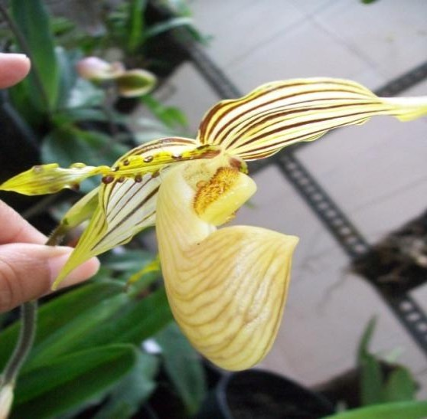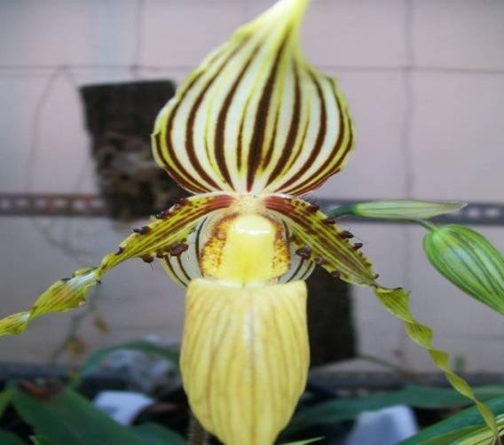

Front view Right view

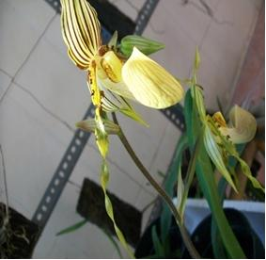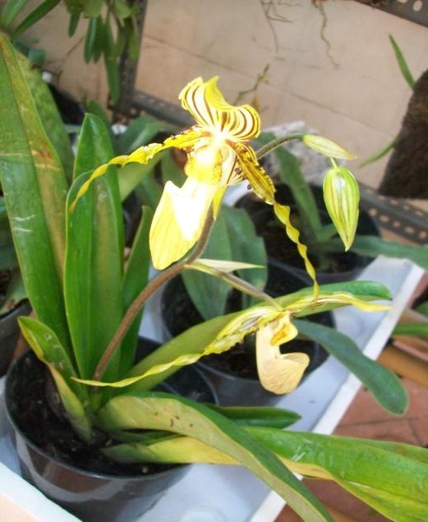

Top view Top-right view

Paphiopedilum glaucophyllum

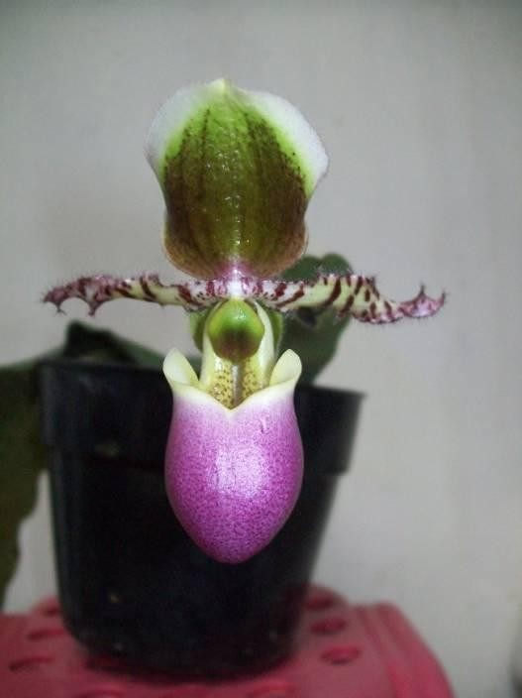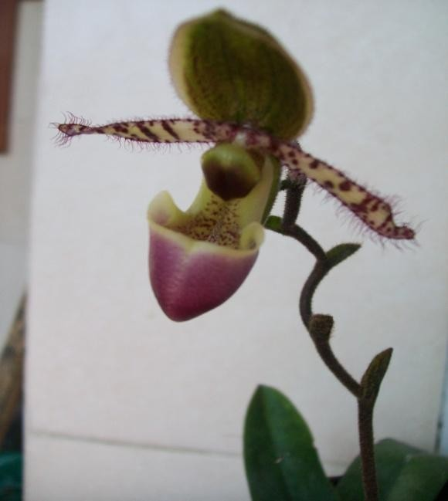

Front view

Paphiopedilum chamberlianum

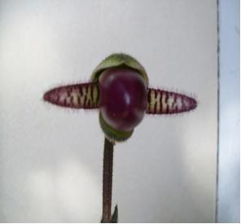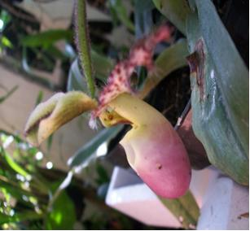

Right view Bud of flower

