Volume 16, Number 3, 2014 © WIETE
2014

Global Journal of Engineering Education

A National Education Policy based ICT Model for Indonesian Vocational High
Schools (VHS)

Hakkun Elmunsyah
hakkun@um.ac.id
Department of Electrical Engineering, Universitas Negeri Malang
Malang, Indonesia

ABSTRACT: Various parties may dispute the government readiness on implementing curriculum 2013. This illustrates that the previous and recent national education policy, teachers and school administrators have not synergize. Therefore, a national education policy-based-ICT model is proposed as a solution to increase the education quality at school especially at Indonesian Vocational High Schools (VHS).The research outcomes are (a) study the development of adaptive ICT model that is relevant to Kemendikbud policy: (1) the result of initial testing shows that the ICT management at VHS Malang Raya is fairly sufficient (54.63%),(2) the expert validation on the developed model illustrated that the research product is applicable (81%); (b) average trainees response (88.8%) indicate that the technology is relevant for VHS stakeholders.

Keywords: curriculum 2013, ICT-model for VHS, MGMP, stakeholders

INTRODUCTION

The rapid development of information and communication technology (ICT) creates more convenient life aspects. The growth shows a drastic improvement in terms of technology and quantity [1]. One success factor of ICT implementation is the characteristic of its users [2]. However, failures in ICT implementation still heard due to users’ behavioral aspect [2,4-6]. Another study on the implementation of information systems, Adam et al [3] explains that the application settings can be used by system designers to obtain user feedback as a step to diagnose the problem in the receipt of information by the user. The specific-psychological behavior within ICT users may influence the success of ICT implementation in various aspects such as government and politics.

Andersen David F et al [7], state that modern ICT may influence the government and politic through four approaches. Firstly, technology may change the detail of government’s operation steps. Secondly, technology may gradually transform the relationship between the voted leader and the technology experts in the government. Thirdly, the government characteristics as public-information resources may transform. Lastly, the development of technology may change the role of the government as the owner of the public-information. In accordance with these ways, citizens may ask the government transparency, freedom to speak and to get information, which are known as democratic pillars.

Indonesian Ministry of Education (Kemendikbud) responded these phenomena through 2005-2014 strategic planning of the department of national education. The department formulates three pillars of natio nal education-public policies; that is, (1) the access expansion; (2) the enhancement on quality, relevancy and competitiveness; (3) the improvement on management, accountability and public image. The products of these policies were national networks for education and electronic version of school textbooks, called Jardiknas (Jaringan Pendidikan Nasional) and BSE (Buku Sekolah Elektronik) respectively. Both created to answer related educational problems through ICT implementation. This is relevant to Miller [8] opinion that ICT based education may generate interoperable, reusable, manageable, accessible and sustainable learning process.

In accordance with the following policies, the government has developed an organization to improve teachers’ professionalism, namely Musyawarah Guru Mata Pelajaran (MGMP). However, the organization has to face financial and technical difficulties since the time it has been established [9].
The recent government’s policy in education is the implementation of the 2013’s curriculum. This educational policy improves the 2004’s competency based-curriculum by integration of attitude, knowledge and skill. This integrated curriculum is developed to boost the performance of education by enhancement of the learning efficiency and learning time at school. In a more detail, the learning effectiveness can be achieved through three efficiency steps of interaction, comprehension and absorption. Here, the expected outcome is efficient-school grades-transformation due to effective interaction between teachers and students for improving students’ understanding. This curriculum promotes a learning approach, is based on personal experience through observation, association, asking question, making conclusion and performing communication.
In fact, the 2013’s curriculum still not equipped with supportive learning resources, for example, syllabi, learning and teaching plan (RPP: Rencana Pokok Pembelajaran), teaching materials, scoring system, etc. It shows that both technical coaching and improving ICT implementations on the curriculum are crucial.

The preliminary research reported that there are significant numbers of ICT implementation at Vocational High Schools (VHS) in District that is still inappropriate to these pre-professional senior secondary schools’ vision and mission. Based on that observation, a research to develop an ICT-model in VHS should be carried out. Here, the role of MGMP, particularly VHS-productive groups, will be enhanced. The developed model will be tuned with the national education policy, especially the implementation of the 2013’s curriculum.

METHODOLOGY

This research uses a research and development (R&D) approach, is divided into two steps. The first stage performs research and data collection for designing the ICT-model for VHS based on the existing management model. Figure 1 shows the model design based on the previous illustration. The design consists of policies and systems as inputs, user’s satisfaction and model impacts. The second step tests the developed model at schools. The research procedures follow
10 stages of Borg & Gall method [10].
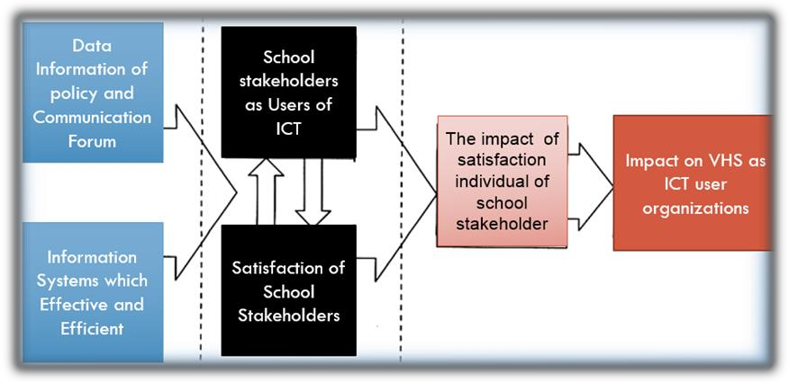
Figure 1. Conceptual Models in Research

Additionally, the R&D approach consists of testing data, data analysis, product revision and final product -analysis.The testing data covers all data collection during the development and testing stages. On the other hand, data analysis examines the survey of the condition of ICT-management at VHS in Malang Raya (City and District of Malang) and investigates the result of product testing. Product evaluation reveals the detail of product alterations. Lastly, the final product analysis describes the model’s strength and effectiveness.

Two approaches of the model testing are expert validation and field testing at VHSMalang Raya. The validation process involves experts in several subjects, such as ICT-management and infrastructure, learning media and administration of vocational education. The respondents of field testing are 50 people of four group ICT-VHS stakeholders. They are 10 administrators, 10 teachers, 10 students (grade XII) and 20 members of MGMP-productive group of MGMP Malang city.

The data collection instruments are (a) the questionnaire of ICT-condition at VHS Malang Raya; (b) the expert validation questionnaire of ICT implementation-model; (c) the questionnaire of model effectiveness on VHS stakeholders. Three analysis techniques of data collection are the analysis of feasibility, instrument validity and reliability analysis and model efficiency analysis.

Instrument’s validity and reliability coefficient should be obtained before distributing questionnaires to the research respondents. The questionnaire is valid if the Corrected Item-Total Correlation score is less than3.0 while the reliability
coefficient at least 0.70 [11]. In this study, the calculation of both scores by SPSS 16.0 for Windows shows that the questionnaire is acceptable with 0.58-0.94 of Corrected Item-Total Correlation and 0.992 ofAlphaCronbach coefficients.

RESULTS AND DISCUSSION

The survey results at VHS-Teknik Komputer Jaringan (TKJ) show that the average of ICT-management aspects is in adequate (40-60%) category.The value indicates that the awareness of the importance of ICT-infrastructures to support VHS TKJ at Malang Raya is quite excellent. Figure 2 shows the comparison between average of various ICT- management aspects of VHS TKJ from City and District of Malang.

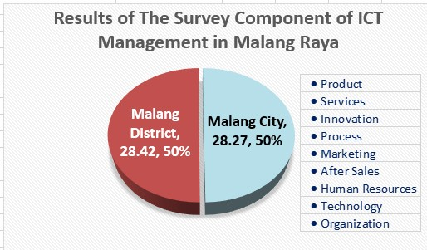
Figure 2.Comparison of ICT-management of VHS City and District of Malang

Based on SWOT analysis, the survey result of ICT-management at VHS TKJ Malang Raya is divided into three following factors.
1) Internal Factors: a) Strengths (S): (1) The availability of novel and robust software and hardware, (2) Head of school commitment to provide the budget for developing ICT at school; b) Weaknesses (W): (1) Master plan of long-term development is unavailable (2) There is no synergy between the ICT development and management.
2) External factors : a) Opportunities (O):(1) Demands of rapid and accurate information (2) ICT-training to improve human resources skill (3) The hardware and software become public commodities; b) Threats(T): (1) Uneven distribution of ICT-experts in VHS-technical units, (2) Imbalanced ICT-distribution in every workgroup and technical unit, (3) The appointment letter (SK) of ICT officers is unavailable.
3) Strategies from SWOT findings: a) Strengths – Opportunities: (1) Optimize the use of hardware and software on information processing and distribution, (2) Optimize the budget for improving human resources’ skills; b) Weaknesses-Opportunities: (1) Improve the human resources’ performance to maximize the ICT implementation, (2) Recruit more ICT-officers; c) Strengths-Threats: (1) equal distribution of ICT on each department at school, (2) letter of assignment for ICT administrator, (3) equal distribution of ICT-competent human resources on each technical unit at school; d) Weaknesses-Threats: (1) create a master plan as a reference of decision making process, (2) even distribution on ICT-infrastructures and experts.

The product will be assessed by experts in various disciplines such as learning media, school management, ICT management and Jardiknas practitioners. Those experts perform evaluation on resource management, school management related to ICT-organization at VHS, and infrastructure management (hardware, software and user). The researcher concludes the expert notes as the product evaluation on model structure and explanation of ICT - implementation of ICT management model at VHS. The average score of both evaluation aspects are 83.75% and
84,38%, which show that the research product is valid for implementation.

The implementation of the developed ICT-model is detailed in these following stages: (a) various trainings for 50 teachers of MGMP-TKJ-VHS of Malang on using website (Figure 3), recent curriculum concept (Kurikulum 2013), creating a teaching plan of a basic TKJ-competency; (b) operational coaching on development and evaluation of current RPP at school; (c) performance assessment for 50 stakeholders in Malang City.
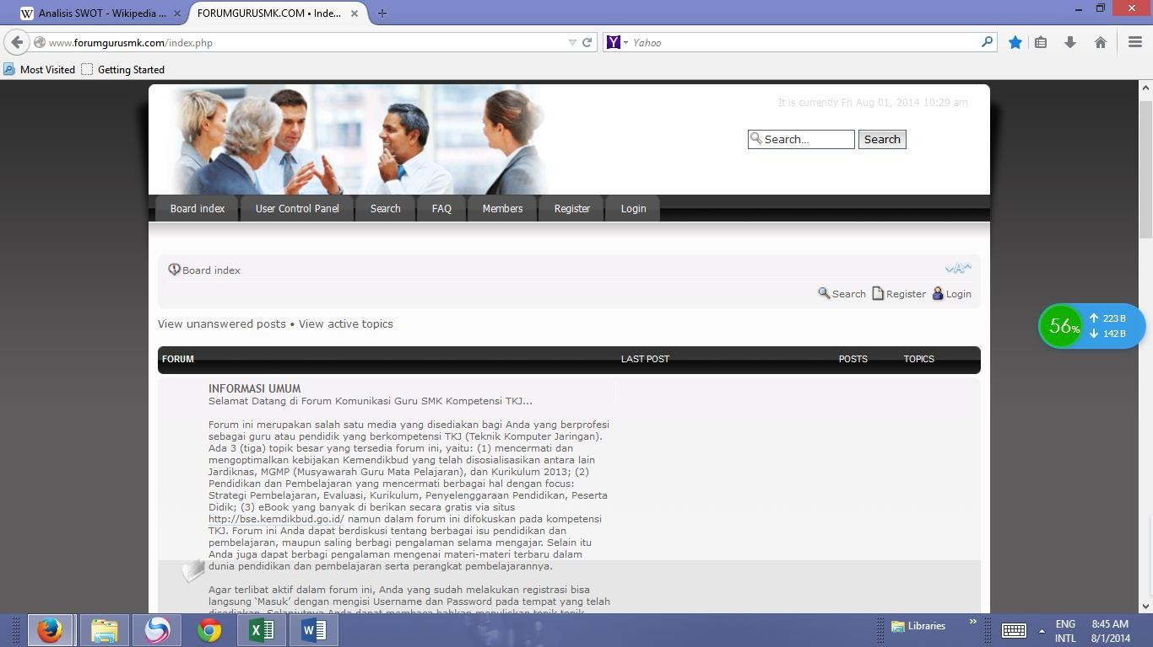
Figure 3. WEB of Vocational Teacher Forums

Generally, the participants’ responses are divided into four groups: (1) Three indicators of training goals on implementation of ICT model; (2) Eight indicators of training materials; (3) Four indicators of discussion substances, (4) Sole indicator of reference list.

The training participants simply grouped into two categories, that is, administrators and teachers. The grouping is necessary since the implementation of kurikulum 2013 required a synergy between teachers and administrators.

As showed in Figure 4, the administrators’ (Adm) responses are higher than MGMP teachers in every aspect. They more likely to know about the subject’s objectives, materials, discussion materials, and references as they indirectly manage the lesson by previous curriculum. The global average of four aspects (88.8 %) shows that the developed ICT model is exceedingly useful.

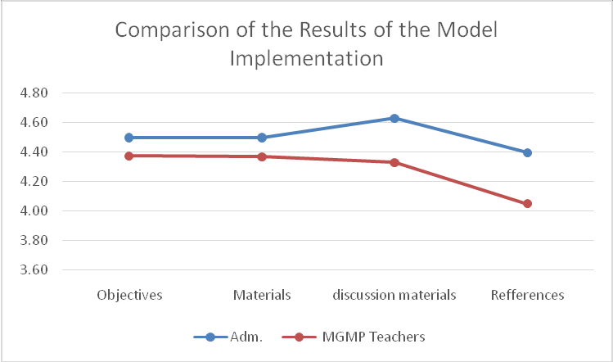Comparison of stakeholder satisfaction showed the improvement on understanding of Kemendikbud policy and using ICT efficiently. The number of WEB users (i.e. VHS teachers forum) are inceasing from 50 MGMP teachers to 785 participants with various educational backgrounds. The implementation result is relatively in line with Gigler [12] dan Schreurs, J. [13] that information is not only a knowledge source but also a special way to promote education, economy, social, politics and culture. In other words, access and the use of ICT is a basic condition of development in every life aspect.

Figure 4. Trainees average score

CONCLUSIONS AND RECOMMENDATIONS Conclusions
The research conclusions are described as follows:
1. The quality of ICT at 42 VHS Malang Raya is pretty feasible (54.63%).
2. In general, the ICT management at those schools matches with the VHS-ICT-management characteristics. The main obstacle is the lack of commitment and ability of the school policy makers which may reduce the alignment of ICT management and Kemendikbud policy.
3. The expert validation on each evaluation aspects show that the model implementation is extremely practical
(81%).
4. The limited trainees’ responses on product testing scale explains that the developed model is exceedingly
applicable (88.8%).

Suggestions
The following suggestions are formulated to increase the quality of the future research.
1. The survey is not limited to VHS-TKJ due to the variety of vocational schools at Malang Raya.
2. Increase the number of respondents to perform more reliable research.
3. Develop the training modules which may increase the teachers’ learning content as well as the role of school production units.
4. Recommend the school policy maker to maintain and improve the leadership and organizational culture on school management staff performance to satisfy the VHS stakeholders.

REFERENCES

1. Jogiyanto. Sistem Informasi Keperilakuan. Yogyakarta: Penerbit ANDI.(2007).
2. Nasution, M.N. Manajemen Mutu Terpadu. Jakarta: Ghalia Indonesia. (2001).
3. Adams, D.S., R.R. Nelson, and P.A. Todd. Perceived Usefulness, Perceived Ease of Used, and Usage of Information
Technology: A Replication. MIS Quarterly, 16,2, pp: 227-247. (1992).
4. Jantan, M., T. Ramayah, Chin Weng Wah. Personal Computer Acceptance by Small and Medium Sized Companies
Evidence from Malaysia. Jurnal Manajemen dan Bisnis, 3,1, pp: 199-216. (2001).
5. Iqbaraia, M., Zinatelli, N., Cragg, P., and Cavaye, A.L.M. Personal computing acceptance factors in small firms: A structural equation model. MIS Quarterly, 21,3:
270-305. . (1997).
6. Ramayah, T., Christine Ong Swan dan Jasman J. Ma’ruf. Faktor-Faktor yang Mempengaruhi Tahap Penerimaan Teknologi Informasi di Kalangan Industri Kecil dan Menengah di Utara Semenanjung Malaysia: Suatu Kajian Awal Aplikasi Technology Acceptance Model. Jurnal Ekonomi dan Bisnis, 3.2, 171-194. (2004).
7. Andersen D. F., et all. Integrating modes of policy analysis and strategic management practice: requisite elements
and dilemmas (with Colin Eden, Fran Ackermann, John M. Bryson, and George P. Richardson), Journal of the
Operational Research Society. (2008).
8. Miller, L.W. (]Computer Integration By Vocational Teacher Educators. Journal of Vocational and Technical
Education 14,1. (2007).
9. Suwarno. MGMP Kejuruan Teknologi Rekayasa dan Teknologi Informasi. Malang: P4TK. (2012).
10. Borg, W.R. & Gall, M. D.Educational Research: An Introductional (TheFifthEdition), New York: Longman, Inc. (1989)
11. Elmunsyah H., Pengembangan Model perluasan dan Pemerataan Akses Pendidikan dalam Mensinergikan Kebijakan Depdiknas pada Implementasi Program BSE di Daerah Pegunungan Kabupaten Malang, Kemendikbud: Jakarta. (2009).
12. Gigler, B.S. Enacting and Interpreting Technology from Usage to Well-being: Experiences of Indigenous People with ICT. Di dalam Empower Marginal Communities with Information Networking. Diedit oleh Hakikur Rahman. Hershey, Pen: Idea Group. 124-164. (2005).
13. Schreurs, J. ICT use in school: vision and performance measures. Villach-Austria: Procceding Conference ICL-
2007. (2007).

BIOGRAPHY

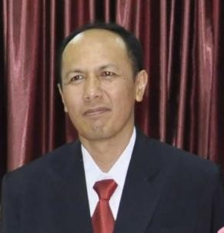Hakkun Elmunsyah was born in Bondowoso, but has been stay in Malang, Indonesia. He got a bachelor degree of electronics from Brawijaya University in 1989. In 1999, he got a BPPS scholarship for a master of engineering program at University of Gajah Mada. Dr. Elmunsyah received his doctoral degree from Yogyakarta State University with a dissertation on Management Model of ICT centers Vocational School (2008). He is a senior lecturer of the department of electrical engineering, State University of Malang (UM) since 1995. During that period, he was appointed as the head of UM computer centre (2003), chairman of electronic journal developers, one of ministry of education’s curriculum instructors and a member of graduate program quality assurance since 2013.

