DESIGNING SERVICE QUALITY MODEL FOR VOCATIONAL HIGHER EDUCATION

Aisyah Larasati1, Laili Hidayati2, and Lismi Animatul Chisbiyah3
1 Department of Industrial Technology – Faculty of Engineering - State University of Malang email: aisyah.larasati.ft@um.ac.id
2 Department of Industrial Technology – Faculty of Engineering - State University of Malang
email: lely_tiftum@yahoo.com
3 Department of Industrial Technology – Faculty of Engineering - State University of Malang email: lismi.chisbiyah@um.ac.id

Abstract

This research aimed to design a service quality model for a vocational higher education. Data was collected through a focus group discussion and an online survey. The focus group discussion involved six groups of student in which each group consisted of seven students. The online survey was fulfilled by 429 students. The results of the focus group discussion was used to determine factors used in the online survey. The results of the online survey were used to build a service quality model using a linier regression and a neural network model. The linier regression model showed the factors that have a significant effect on the service quality were the condition of the classroom, the laboratory, and the supporting infrastructure. On the other hand, the neural network model showed the factors that influenced service quality were the condition of the classroom, the supporting infrastructure, and the service delivered by the laboratory staff. These results implied that even though in vocational higher education curriculum, the theory content was only 30% of the entire course load, the condition of the classroom was still has a significant effect on student satisfaction.

Keywords: linier regression, neural network, service quality, vocational higher education

1. INTRODUCTION
An excellent service quality in a
vocational higher education has an important role to increase student loyalty and to attract
potential new students. A vocational higher education that delivers an excellent service quality tends to have a lower turnover in its students and to have a high number of new students’ enrollment. As a result, the vocational higher education institution tends to have a secure financial situation. This reality has encouraged each department to improve its service quality continuously. Total quality management, which is based on voice of customer, is one of the available approaches to be implemented in order to provide best service quality [1].
During the initial observation in Department of Industrial Technology, the current document of the Quality Assurance
Taskforce showed that the process to assure the service quality delivered by the department was based on general aspects only. The documents did not consider the unique characteristics of each department. Furthermore, these documents also did not consider voice of customer as main factors in assuring service quality. Thus, the quality assurance process has not been focused on the needs of students. Service quality improvement that fulfills students’ needs is able to increase students’ satisfaction. Therefore, it is important to explore determinant factors of service quality in order to direct service quality improvement met the department targets, which are to minimize students’ turn-over rate and maximize student satisfaction [2].
This study aims to explore factors that affect the service quality delivered by

Department of Industrial Technology of State University of Malang and to determine its importance level using two approaches, a linear regression and a neural network model. This study differs from other studies in service quality since this study do not use a quantitative approach to identify the determinants of service quality as the earlier study conducted by Houston [6] and Tsinidou, Gerogiannis & Panos Fitsilis [7]. This study applied a qualitative approach that aimed to explore the opinions of the students by conducting focused group discussions (FGD). Also, the service quality model was built by using a statistical model (linier regression model) and a neural network model. These two models are well known for their accuracy on studying causal relationship and prediction cases [8].

2. LITERATURE
An excellent quality of education services
has an important role on improving the competitiveness of a higher education institution, including a vocational higher education, and increasing the motivation of all entities in the university to achieve the vision and mission of the institution. In addition, an open attitude of the policy maker in the higher education institution toward feedback also enables the university to be continuously improved [3]. The revitalization of service quality delivered by a department in higher education is critical to achieve all stakeholder satisfaction. However, revitalization of service quality that does not consider voice of customer is useless. In the vocational higher education context, voice of customer may be interpreted as students’ needs. Students’ dissatisfaction toward service quality delivered by the department may trigger decreasing students’ motivation to study, increasing students turn-over rate or even lowering a new student enrollment [4]. Students’ dissatisfaction is easily to spread out through word of mouth. Thus, exploring determinant factors of student satisfaction is important while designing service quality in vocational higher education [2]. One of the most challenging processes when designing a
service quality model in a higher education institution is to determine who should be the consumer and how to measure consumer perceptions of the service quality [5].

3. METHODS
This research was conducted in Industrial Technology Department - State University of Malang. This department was comprised of two study programs: culinary study program
and fashion design study program. These two study programs were categorized as a vocational higher education. Both of these programs offered associate degrees and bachelor degrees. The summary of the research methodology used in this study is shown in Figure-1.

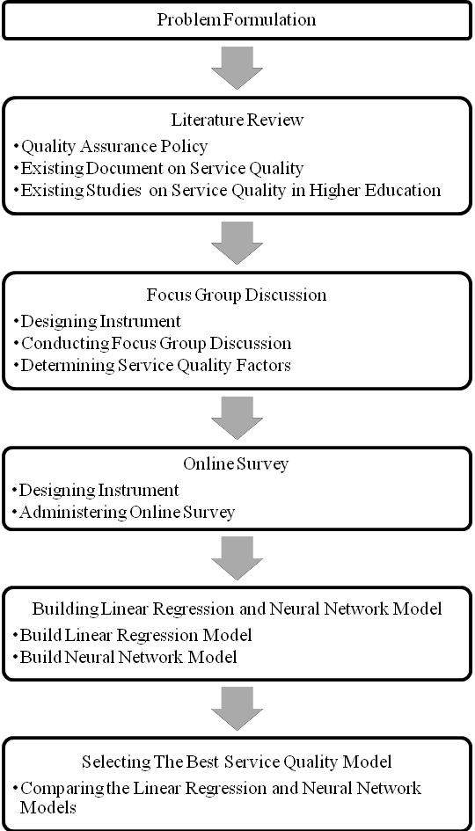

Figure-1. Research Methodology

This research used a quantitative descriptive design and cross sectional data. Data were collected in two phases: a focus group discussion and an online survey. The first phase aimed to collect students’ perception on important factors that influenced their satisfaction toward service quality delivered by the department. This phase was a focus group discussion which involved six groups of students. Each group consisted of seven students and have to discuss six open questions related to service quality delivered by the department. The sampling technique used in focus group discussion was a purposive sampling in order to get student representation, which were able to express their opinion critically. In addition, the students who were involved in the focus group discussion must be at least in the sophomore year (have been studying in Department of Industrial Technology at least for one year). This criterion was used to ensure that the students have already had enough experience with service delivered by the department. The results obtained from the focus group
model. The neural network model was built using multilayer-perceptron architecture with two hidden layer. Model that resulted in the lowest square error was used to design the service quality model. Error in this study was measured as the difference between predicted value resulted from the models and the real value obtained from students perception given on the online survey.

4. RESULTS AND DISCUSSION
Seven factors that were mostly discussed
by the panel during focus group discussion were shown in Table 1. This results show that
service quality delivered by the faculty members were the most important factors that the students perceived as determinant to their satisfaction. In contrast, quality of student association activities was the least important factor that effect on their satisfaction toward service quality delivered by the Industrial Technology Department.

Table 1. Results of Focus Group Discussion Factors Importance
discussion were used to design the online Rank
survey.
The second phase of data collection was to collect data using the online survey. This phase aimed to measure students’ satisfaction
and the importance level of each factor that affected their satisfaction toward service quality delivered by the department. All of Industrial Technology Department students got an email invitation to participate in the online survey. This survey asked the students to answer 31 close-ended question related to service quality delivered by the department.
A qualitative approach and statistical descriptive technique was used to analyze focus group discussion data. The service quality models were built by using linear regressions and neural networks. The input variables of these models were derived from the online survey questions. Confirmatory Factor Analysis was used to reduce number of variables included in the linear regression and neural network models. Stepwise approach was used to determine the significant input variable included in the linear regression
Service quality of the faculty 1 members
Quality of the laboratories 2
Quality of the classrooms 3
Quality of supporting 4 infrastructures
Service Quality of the laboratory 5 and administration staff
Quality of Curriculum 6
Quality of Students 7
Association’s activities

The results of the focus group discussion showed various students perception toward factors that influence service quality delivered by Industrial Technology Department. This variety could occur due to diversity of students’ point of views on defining service quality. Students as one of the stakeholders in the vocational higher education institution had diversity in the assessment because students could take different courses, taught by different faculty members, or experienced different laboratory practices, which resulted

in different experiences as a student. Therefore, the assessment of the service quality of higher vocational education should be evaluated for each department and not for all departments at the university level. As Quinn et al [5] found on their study that the homogeneity of students used in evaluating the quality of service was required to represent students’ perceptions of higher education services.
This study also founds that service delivered by faculty members play an important role to the quality of service in vocational higher education. This findings was in line with Quinn et al [5] that concluded three factors of service quality in higher education was academic services, administrative services, and service support activities. Voss, Gruber, & Szmigin [4] also found that faculty ability and enthusiasm, friendliness, and easiness to be contacted was significantly affect students perception toward their satisfaction.
Other than service of faculty members, results of the focus group discussions also found that the relationship with industry,
convenience features and cost were the other factors that affected service quality of a vocational higher education services. According to Angell, Heffernan & Megicks [2], service delivered by the faculty and the ability to establish relationships with industry is more important than comfort feeling toward university environment and facilities costs. In addition, the academic staff, administrative services, library services, structure of curriculum and the location of the university was also significant factors that influenced service quality in higher education [7].
In addition to factors related to academic condition, results of the focus group discussion also found that practices courses that involved
wider community such as fashion exhibition and culinary exhibition as well as extra- curricular activities organized by the Student Association of Industrial Technology (HIMTI), such as fashion carnival, also
influenced student satisfaction on the service quality delivered by Industrial Technology Department. This findings was in line with Douglas, McClelland, & Davies [9] which found that some factors that influenced student satisfaction was comfortable feeling to socialize and communicate as well as facilities and supporting facilities designated for student activities. Students would like express their abilities and talents not only in academic activities but also in extracurricular activities. Houston [6] mentioned that problem of service quality was gradual and cumulative. Dissatisfaction experienced by students would continue to increase from one semester to the next semester if there was no systemic improvement performed by a higher education institution in term of its service quality.
The results of focus group discussion were used to design the online survey. Students’ response on the online survey was categorized using confirmatory factor analysis based on the factors in Table-1. Then, the output of the confirmatory factor analysis was used as input variables on the linear regression and the neural network models.
The linear regression model was built using stepwise approach as the variable selection method. Model summary of the linear regression model was shown in Table-2 and the coefficient was shown in Table-3. Based on the results shown in Table-2 and Table-3, this study used the third model as the service quality model for the department. The significance value of the third model < 0.05 means that the third model was able to explain the relationship between independent and dependent variables used in this research. This model included three factors, which were quality of the classrooms, quality of supporting infrastructure, and quality of the laboratory with the mean square of residual of 0.564. These three factors have a statistically significant effect on service quality. Quality of the classroom has the highest influence and quality of the laboratories has the lowest influence on the service quality.

Table 2. Linear Regression Model Summary

Model |  | R | R  square |  | Sum of  Squares |  | df |  | Mean Square | F | Sig.
1 | Regression | 0.723a | 0.523 |  | 260.80 |  | 1 |  | 260.803 | 450.23 | 0.000a
 | Residual |  |  |  | 238.08 |  | 411 |  | 0.579
 | Total |  |  |  | 498.88 |  | 412
2 | Regression | 0.729b | 0.531 |  | 265.08 |  | 2 |  | 132.542 | 232.43 | 0.000b
 | Residual |  |  |  | 233.80 |  | 410 |  | 0.570
 | Total |  |  |  | 498.88 |  | 412
3 | Regression | 0.733c | 0.538 |  | 268.20 |  | 3 |  | 89.398 | 158.50 | 0.000c
 | Residual |  |  |  | 230.69 |  | 409 |  | 0.564
 | Total |  |  |  | 498.88 |  | 412
a. Predictors: (Constant), quality of the classrooms
b. Predictors: (Constant), quality of the classrooms, quality of the supporting infrastructures
c. Predictors: (Constant), quality of the classrooms, quality of the supporting infrastructures, quality of the laboratories

Table 3. Coefficients of Linear Regression Model
Unstandardized
Coefficients
Standardized
Coefficients
Model
B Std. Error B T Sig.
1 (Constant) 4.017 0.037 107.259 0.000
Quality of the classrooms 0.796 0.037 0.723 21.219 0.000

2 | (Constant) |  | 4.017 |  | 0.037 |  |  |  | 108.104 0.000
 | Quality of the classrooms |  | 0.719 |  | 0.046 |  | 0.654 |  | 15.487 0.000
Quality of supporting
infrastructure 0.127 0.046 0.116 2.740 0.006
3

Quality of supporting
(Constant) | 4.017 |  | 0.037 |  |  |  | 108.698 |  | 0.000
Quality of the classrooms | 0.756 |  | 0.049 |  | 0.687 |  | 15.504 |  | 0.000

infrastructure 0.156 0.048 0.142 3.266 0.001
Quality of the laboratories 0.105 0.045 0.095 2.349 0.019

A neural network model was built using a mulitilayer-perceptron architecture because this type of architecture has many similarities to linear regression compared to other type of architecture of neural network model, such as input layer (independent variables), output layer (dependent variable), and functions that connect input and output. This study used sigmoid activation function in the hidden layer since the distribution of the dependent variable data was suitable with that function. Detail information of the neural network model built in this study is shown in Table-4. The architecture of the neural network built is shown in Figure-2.
The neural network model shown in Figure-2 indicated that the model was built using seven processing elements (PE’s) in the input layer and one processing element (PE) in the output layer. The result of the neural network model, shown in Table-5, indicated that the sum squares error on the training data was 0.358 and the sum square error of the testing data was 0.016. These errors (difference between predicted value and real data) were lower that the square error obtained from the linear regression model. It indicated that the neural network model performed better in representing the service quality of the case study.

Table 4. Neural Network Information

Type of Layer Information

Input Layer | Factor 1  Factor 2  Factor 3 |  | Service quality of the faculty members  Quality of the laboratories  Quality of the classrooms
 | Factor 4 |  | Quality of supporting infrastructures
 | Factor 5 |  | Service Quality of the laboratory and
 |  |  | administration staff
 | Factor 6 |  | Quality of Curriculum
 | Factor 7 |  | Quality of Students Association’s
Hidden Layers | Number of Unitsa |  | activities  930
 | Number of Hidden Layers |  | 2
 | Number of Units in Hidde  Layer 1a | n | 20
 | Number of Units in Hidde  Layer 2a | n | 15
 | Activation Function |  | Sigmoid
Output Layer | Dependent Variables |  | 1
 | Number of Units |  | 1
 | Rescaling Method for  Dependents |  | Normalized
 | Activation Function |  | Sigmoid
 | Error Function |  | Sum of Squares

H1 H1

Factor 1
H2 H2

Factor 2

Factor 3

Factor 4

H3 H3

Service
Quality

Factor 5

Factor 6

… H4

f(sigmoid)

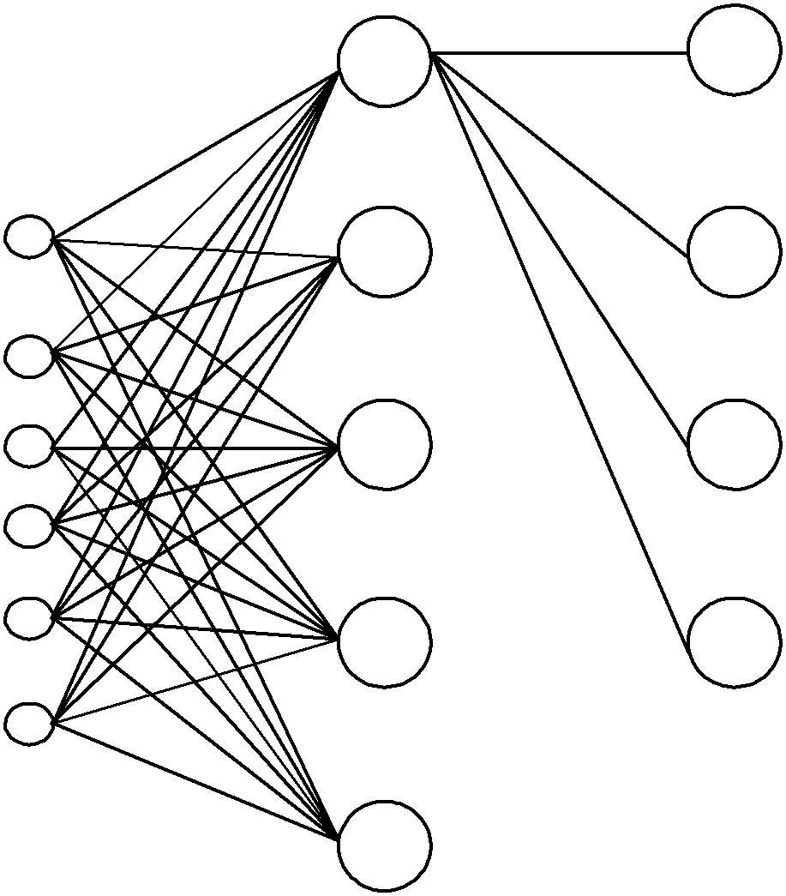Factor 7

f(sigmoid)

H20

f(sigmoid)

H15

INPUT LAYER (7 PE)
HIDDEN LAYER I
HIDDEN LAYER II
OUTPUT LAYER (1 PE)

Figure 2. The Architecture of the Neural Network Model

Table-5. Neural Network Model Summary Type of
Dataset Information
Training Sum of Squares
Error 0.358
Relative Error 0.058
are different. The linear regression used the quality of laboratory, while the neural network model used the service quality of the laboratory and administration staff.
Quality of classrooms and supporting infrastructure were two factors that were easily
Stopping Rule
Used

Testing Sum of Squares
5 consecutive step(s) with no decrease in error
to be judged by students. As Angell, Heffernan
& Megicks [2] found, university environment and facilities significantly influenced students’ perception toward service quality. Classrooms
and supporting facilities easily noticed by
Error 0.016
Relative Error 0.196

Table-6. Neural Network Model Output Normalized
Factors Importance Importance
Quality of the
classrooms 0.236 100.0%
Quality of
students. First impression of service quality delivered by an education institution was its classrooms and supporting facilities. Thus, maintain an excellent classrooms environment and supporting facilities might improve students’ perception on the delivered service quality.
Both linear regression and neural network models showed that laboratory either the
supporting infrastructures Service quality of the laboratory and administration staff
Quality of student association
activities
Quality of the
0.158 67.0%

0.140 59.3%

0.120 51.0%
quality of the laboratory or the service
delivered by the laboratory staff had
significant effect on the perception of students toward service quality in the vocational higher education institution. This factor was close related to the practicum process in the laboratory. Service quality during the practicum process might be influenced several factors, such as number of tools and equipment available during practicum, capability of the
laboratory 0.118 50.2%
Quality of the
curriculum 0.116 49.2%
Service quality of
laboratory staff, laboratory environment, and also state-of-the-art of the tools and equipment used during practicum. Laboratory and practicum were two things that were really
the faculty members
0.111 46.9%
important in vocational higher education. As
written in the curriculum of Department of
Industrial Technology as one of vocational
The neural network model output, shown in Table 6, indicates that the final neural network model used all of the seven factors as its input. Quality of the classrooms has the highest influence and service quality of the faculty member has the lowest influence on the service quality delivered by the department. As shown in Table 3 and Table 6, two of the most influence factors on service quality based on the linear regression and neural network were similar. These two factors are quality of the classrooms and supporting infrastructure. However, the third factor used in both model
higher education institution, practicum load was approximately 70% of the total course load. Thus, quality of laboratory and service delivered by the laboratory staff played a critical role on students’ perceived service quality. In order to gradually and continuously improve service quality, decision maker in a vocational higher education institution should consider to increase the number of tools and equipment to make a balanced ratio between number of students and number of tools and equipment. In addition, providing brand new tools and equipment in order to make the

laboratory get closer to students need and the industrial needs was also urgent.

CONCLUSION
Based on the focus group discussion,
factors that influence students’ perception
toward service quality in vocational higher education are: 1) service quality of the faculty members, 2) quality of the laboratories, 3) quality of the classrooms, 4) quality of supporting infrastructures, 5) service quality of the laboratory and administration staff, 6) quality of curriculum, and 7) quality of students association’s activities. These results imply that the policy maker at the level of department/faculty/university should create and maintain academic environment that open to students’ feedback and responsive to students’ needs since academic environment is dynamic and changing continuously. By accommodating students need, a vocational higher education institution is able to minimize students’ dissatisfaction and to increase academic environment and financial stability since students’ turn-over rate can be minimized. As a result, the collaboration among students, faculty member, laboratory staff and administration staff can be optimized to achieve the university vision, mission, and objectives.
The service quality model obtained from the linear regression model indicated that the service quality delivered by Industrial Technology Department was statistically influenced by the quality of the classrooms, the supporting infrastructures, and the laboratory. The mean square error of this model was
0.564. In addition, the neural network model
indicated that the service quality delivered by the department was influenced by the quality of the classrooms and supporting infrastructures, and the service quality delivered by the laboratory and administration staff. The mean square error of the neural network model on the training data was 0.358 and the mean square error on the testing data was 0.016. Since the mean square error obtained from the neural network model was lower than the one obtained from the linear regression model, then the neural network
model was better than the linear regression model to represent the service quality of the Industrial Technology Department.
This study also concluded that problems of students dissatisfaction in a vocational
higher education institution were not only
caused by the end results of the service quality delivered by the department, but it also caused by the imperfect process when delivering service to students either by faculty members, laboratory staff, or administration staffs. Therefore, a vocational higher education institution should not only be focused on the end result of service quality, but also focused on the delivering process of the service. In addition, a vocational higher education institution was also suggested to avoid doing a sudden and temporary quality improvement. In contrast, a quality improvement should be implemented continuously and periodically.

ACKNOWLEDGEMENT

This article has been published in International Journal of Applied Engineering Science ISSN 0973-4562 Volume 9, Number 22 (2014) pp. 15167-15177.

REFERENCES

[1] K. Baird, K.J. Hu, and R. Reeve, The relationships between organizational culture, total quality management practices and operational performance, International Journal of Operations & Production Management, Vol. 31(7), pp.
789 – 814, 2011.
[2] R. Angell, T. Heffernan, and P. Megicks, P, Service quality in postgraduate education. Quality Assurance in Education, Vol. 16 Iss: 3, pp. 236 – 254,
2008.
[3] K.C. Tan and S.W. Kek, Service quality in Higher Education using an enhanced SERVQUAL approach. Quality in Higher
Education, Vol.10 Issue: 1, pp. 17-24,
2004.
[4] R. Voss, T. Gruber, T., and Szmigin, Service quality in higher education: The role of student expectations. Journal of

Business Research, Vol. 60, pp.949–959,
2007.
[5] A. Quinn, G. Lemay, P. Larsen, and D.M.
Johnson, Service quality in higher education. Total Quality Management,
Vol.20 Issue: 2, pp.139-152, 2009.
[6] D. Houston, Rethinking quality and improvement in higher education, Quality Assurance in Education, Vol. 16 Iss: 1, pp. 61 – 79, 2008.
[7] M. Tsinidou, V. Gerogiannis, and P.
Fitsilis, Evaluation of the factors that determine quality in higher education: an empirical study. Quality Assurance in
Education, Vol. 18 (3), pp. 227-244,
2010.
[8] A. Larasati, Comparing the Performance of Ordinal Logistic Regression and
Artificial Neural Network when Analyzing Ordinal Data, Ph.D. Dissertation, Oklahoma State University, USA, July, 2012.
[9] J. Douglas, R. McClelland, and J. Davies, The development of a conceptual model of student satisfaction with their experience in higher education. Quality Assurance in Education, Vol. 16 Issue: 1 pp. 19 – 35, 2008.

