M. Alfian Mizar. Appropriate technology adoption empirical model for performance improvement of small industries. International Journal of Academic Research Part A; 2013; 5(6), 220-224. DOI: 10.7813/2075-4124.2013/5-6/A.28

APPROPRIATE TECHNOLOGY ADOPTION EMPIRICAL MODEL FOR PERFORMANCE IMPROVEMENT OF SMALL INDUSTRIES

M. Alfian Mizar

Jurusan Teknik Mesin Fakultas Teknik, Universitas Negeri Malang, Jl. Semarang 5 Malang (INDONESIA) fianmz@yahoo.com

DOI: 10.7813/2075-4124.2013/5-6/A.28

ABSTRACT

Technology adoption in small Industries have been constrained by the technology readiness level of the output, and the limited ability of human resources (HR entrepreneurs) in small industries. This research aims to develop a model system for the adoption of appropriate technology (TTG), implementation and diffution to spurad option of TTG in small industry to improve its performance. Data analysis uses an SEM (Structural Equation Model) to test the goodness of fit model, in order to obtain the “empirical model” of technology adoption system. These results indicate that the variable success of the application of technology, (Kapentek) first greatest effect, variable speed technology adoption (Kadoptek) second biggest influence, and entrepreneur readiness variables (Kapeng) third largest effect. These three variables significantly influence the level of adoption of the variable Appropriate Technology (TATTG), the formulation of the model is: TATTG = 0.430 (Kadoptek) + 0.488 (Kapentek)
+ 0.132 (Kapeng).TATTG variables affect variable-tech capabilities (Kabertek), whereas TATTG variables significantly influence the performance improvement variable of Small Industries (PKIK).

Key words: Empirical Models of Technology Adoption, Appropriate Technology, Small Industries

1. INTRODUCTION

Almost all countries rely on the dominant role of small and medium industries (SMIs) in economic growth. The main problem lies in the technological aspects of SMI and management in a series of industry events. To overcome these problems, necessary human resources with competence in the field of technology and management, has the innovative ability to identify,analyze and find solutions to problems, and implement them for the development and management of production processes in SMIs [1,2].
Associated with the settlement of this problem should attempt to encourage increased adoption and technology adoption among businesses, in order to empower and develop a competitive SMI, including through the development of technologies for the SMI support system in an integrative way [3,4]. If the application of the technology among SMIs in Indonesia are taken, it is likely that the cultivated goods in the market will replaced with imported products are more efficient and cheaper.Delay in IKM adopting appropriate technology or research results are due to various causes, including human resources in SMEs, and the weakness of the link between technology providers to the public (HPI). According to Sudaryanto [5], technology adoption by SMEs is still low when compared with the demands of business in the field, so the IKM opportunity should be used in Indonesia to seize imported products.The adoption of technologyby SMIs in Indonesia can be said to be way behind competing countries like China and some ASEAN countries, such as Malaysia, Thailand, and Singapore.
Scheme in (Figure 1) indicate a gap findings with SMI needs. The gap is partly due to: (1) the limited ability of SMIs in adopting the technology (2) has not been a lot of technology needs based on real needs required by the SMIs in order to be a solution for a problem that it actually faces. That is, the application of technology in SMIs is less precise (Inappropriate) generally; research and development institutions in Indonesia do not have a systematic model of technology adoption.

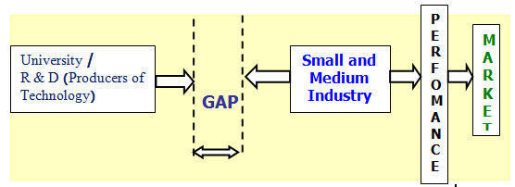
Fig. 1. Scheme of the Gap of R & D by SMEs Requirement

Although the issue of technology adoption has become a strategy for SMIs and technology-producing organizations, many studies show that technology adoption in SMIs is still a problematic area. Strategic decision, such as the allocation of resources to get the technology and develop technology skills, must be analyzed comprehensively [6]. A common criticism that often arises in this connection is that the application of technology in SMIs is inappropriate. Being aware of such a reality, the adoption of technology by people, especially small industries need to get a special study,so as to avoid non technological adoption and unpredictable positive impact on economic and social development of the capacity of receiving communities (small industries).To meet the needs mentioned, this research aims to develop a model system to adopt Appropriate Technology (TTG),Implementation and diffusion to spur adoption of TTG in small industry and improving its performance. Benefits of this research are to provide an empirical grounding system model for the adoption of TTG performance improvement in small industries;as a decision-making for small industries in adopting TTG, and can be used as a guide to policy formulation and adoption of TTG for small industry performance.

2. RESEARCH METHOD

Respondents of this study are the small industries in East Java, some 100 small industries were used as samples were determined by purposive and random sampling. Data was collected by using questionnaires and integrated observation; data analysis was performed using the Structural Equation Model (SEM), with the following procedures in figure 2.

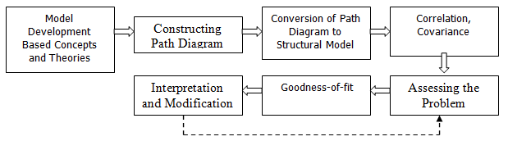Fig. 2. Process of Structural Equation Modeling [7,8]

3. RESULTS AND DISCUSSION

The final SEM analysis results of the final stages of producing the model as shown in Figure 3 with the test results Goodness-of-Fit Overall SEM model as explained in Table 1.The test results show that this is a good model for effective technology adoption (TTG) in small industry.

Table 1. Value of Goodness-of-Fit Indices and critical value of SEM

Criteria | Critical value | Test Results | Explanation
χ2 - Chi Square  Chi Square/DF  RMSEA GFI AGFI TLI | non significant  ≤ 2,00  ≤ 0,08  ≥ 0,90  ≥ 0,90  ≥ 0,90 | 326,210 (p=0,000)  1,365  0,061  0,804  0,734  0,936 | Marginal Good Good Marginal Marginal Good

-,05
,07 ,03

,20
,10
e8
,12
e7
,15
e6
,11
e5
,08
e4
,17
e3
,20
e2
1
d1,30 X1
1

1,05
1 1 1
1 1 1
d2,20 X2
1,28
,17
Y8 Y7 Y6
Y4 Y3 Y2
,9 3,
1
Y5

1
d3,21
,81
X13,00
Kadoptek
,3, 19,41 ,76
1
1,002 ,8 61
1
d4,18
1
d5
X4,46
X5
z2 Kabertek

,20
1
d6,14 X6
,79,13
,0,150
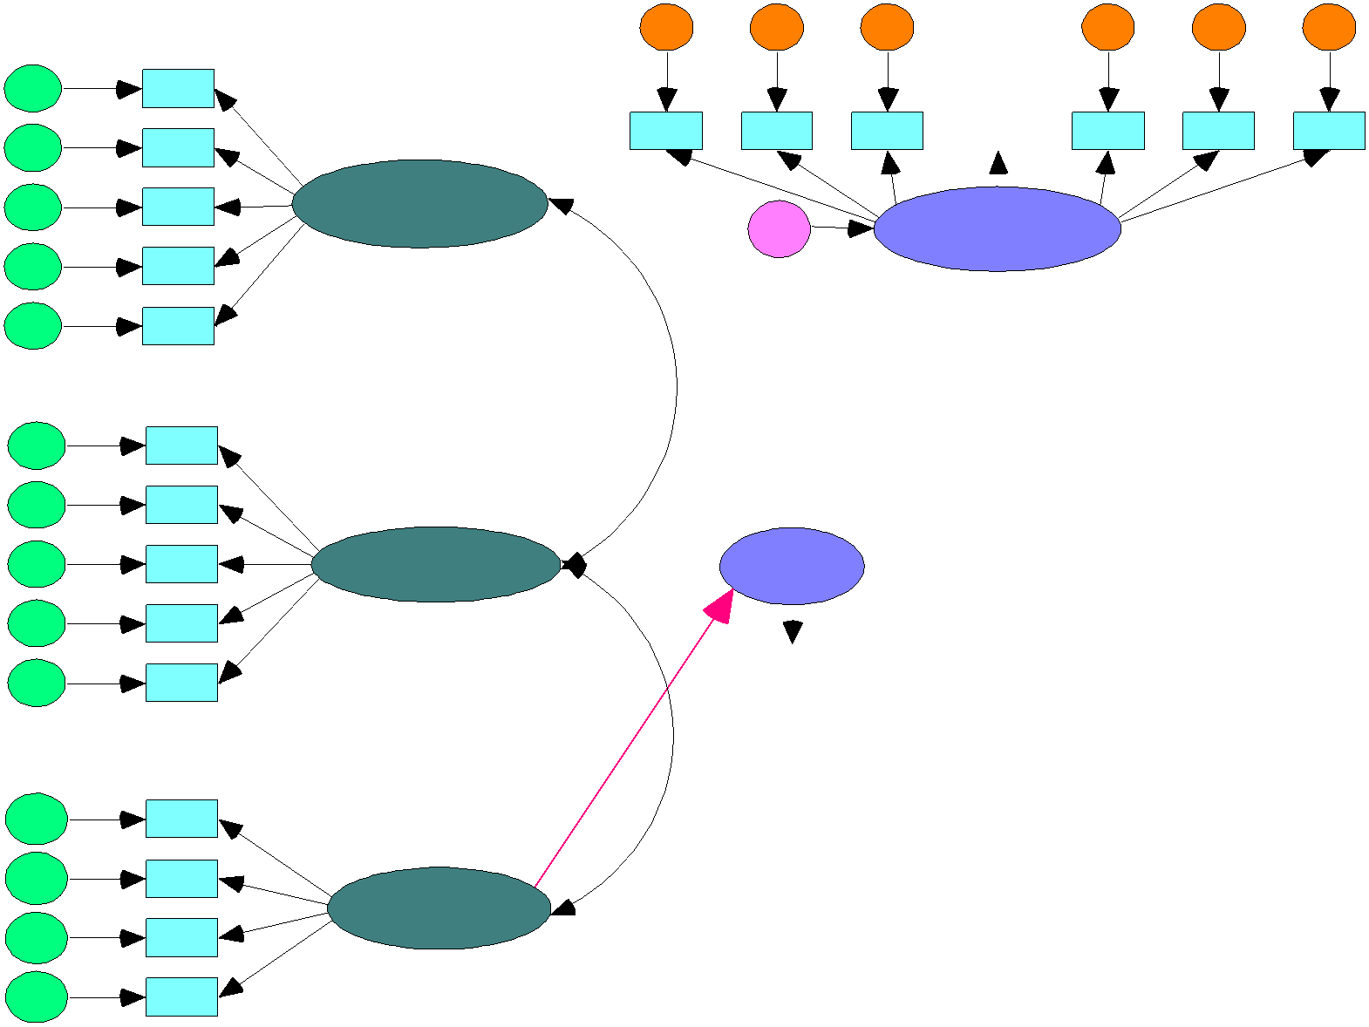z1
,12

,13
z3 1 ,
1
d7,22 X7
1,82
1,79

,08
1
1,04
1 1,00 Y9 e9
1,03 1 ,
1
d8,33
1
d9,29
1
d10
1,53
X81,00
X9 ,74

X10
Kapentek

,23
1,31
TATTG
,06
1,00
Y1
1 | ,

26
PKIK
Y10
1,10
1
Y11
e10
,
e11
,10
1
d11,63
1

X11

1,43
1,43

,20
,05 e1
d121,35 X12
Kapeng
1
d13,54
1
d14
1,41
X131,00
X14
Goodness of Fit
Chi Square = 326,210 probability = ,000
CMIN/DF = 1,365
RMSEA = ,061
GFI = ,804
AGFI = ,734
TLI = ,936

Fig. 3. Appropriate technology adoption model (TTG) in small industry

Based on the results of the final stages of testing SEM has shown that the model is fit for use, for the purposes of hypothesis testing to know whether there is a significant effect that can be seen through the regression weight andcoefficient path test.Coefficientpath test results are presented in Table 2.

Table 2. Research Hypothesis Testing

Hypothesis | Independent  Variables | Dependent  Variables | Direct effect  (Estimate) | Indirect Effects  (Estimate) | Total effects  (Estimate) | p-value | decision
H-1.
a. | Technology  Adoption  velocity | Levels of  Technology  Adoption | 0,430 | 0,000 | 1,430 | 0,047 | accepted
b. | Success  implementation of technology | Levels of  Technology  Adoption | 0,488 | 0,000 | 0,132 | 0,044 | accepted
c. | Entrepreneur readiness | Levels of  Technology  Adoption | 0,132 | 0,000 | 0,132 | 0,043 | accepted
H-2.
a. | Levels of  Technology  Adoption | Small Industry  Performance | 0,869 | 0,051 | 0,920 | 0,000 | accepted
H-3.
a. | Levels of  Technology  Adoption | technological capabilities | 0,655 | 0,000 | 0,655 | 0,000 | accepted
b. | technological capabilities | Performance  Improvement of  Small Industry | 0,078 | 0,000 | 0,078 | 0,331 | rejected
c. | Levels of Technology Adoption | Performance Improvement of Small Industry |  | 0,051 (Indirect Effects)  < 0,869 (direct effect) |  |  | rejected

a) Hypothesis Test 1

Based on the results of the hypothesis testing using path analysis on the model of Structural Equation Modeling (SEM), shows the extent of the influence coefficient of 0.430, and has a significance level with a p-value of 0.047 (well below 0.05.)Based on the analysis above the formulated models of the influence of Technology Adoption Speed (Kadoptek), Technology Implementation Success Factors (Kapentek), Readiness of Entrepreneurs (Kapeng) and the Technology Adoption Rate (TATTG) are as follows: TATTG = 0,430 (Kadoptek)
+ 0,488 (Kapentek) + 0,132 (Kapeng).

b) Hypothesis Test 2

Based on the results of hypothesis testing using path analysis on the model of Structural Equation Modeling (SEM), shows the extent of the influence coefficient of 0.869, and has asignificance level with a p-value of 0.000 (well below 0.05.)Based on the analysis above the formulated models of influence Factors of Technology Adoption Rate (TATTG) and to increase performance in Small Industries (PKIK) are as follows: PKIK = 0.869
TATTG

c) Hypothesis Test 3

Based on the results of the hypothesis testing it can be seen that the level of technology adoption has a direct influence on the ability of tech. Also note that the ability of tech does not have a direct influence on the performance improvements of small industries. It can be seen from the estimate value of the effect of the level of technology adoption-tech capabilities is 0.655 (P = 0.000 &lt;0.05) and the estimate value of tech ability to influence technology adoption rate of 0.326(P = 0.000 &lt;0.05), while the estimate value that directly influence the ability of technology to increase the performance of small industries is 0.078 with (P = 0.331&gt; 0.05), which means it is not significant.

1. Discussion on Influence Factors Against fast Technology Adoption Level

It can be explained from the Hypothesis testing results that the magnitude of the influence coefficient is
0.430, and has a significance level with a p-value of 0.044 (well below 0.05.)Meaning, hypothesis 1 (H-1b) which states that the speed of technology adoption factors has a positive effect on the level of technology adoption in small industries is proven to be correct (acceptable).It shows that the level of technology adoption speed will have an impact on the level of technology adoption in small industries.Structural coefficient on the rate of technology adoption is equal to 0.430, this means that for every 1 unit increase in the speed of technology adoption will
increase the rate of technology adoption by 0.430 units.

Level
2. Discussion on Technology Implementation Success Factors and Influence Of Technology Adoption

The results of hypothesis testing can explain the coefficient effect of the Technology Implementation Success (Kapentek).The Technology Adoption Rate (TATTG) is equal to 0.488, as well as having a significance level with a p-value of 0.044 (below0.05).Thus, Hypothesis 1 (H-1a), which states that the successful application of the technology factor has a positive effect on the level of technology adoption in small industries, is acceptable.

3. Discussion on Influence Factors Against Employers Readiness Level Of Technology Adoption

The hypothesis test results indicate that the magnitude of the influence coefficient is 0.132, and has a significance level with a p-value of 0.043 (still under 0, 05).That is, hypothesis 1 (H-1c) which states that employers readiness factors positively impact the rate of technology adoption in small industries is proven correct (acceptable).It shows that the entrepreneur readiness factors will have an impact on the level of technology adoption in small industries. Structural coefficient readiness of entrepreneurs on technology adoption rate is
0.132; this means that for every 1 unit increase in the readiness of employers will increase the rate of technology adoption by 0.132 units.

4 Discussion onEffect of Adoption of Technology on Performance Small Industries

Based on the results of the path analysis model of Structural Equation Modeling (SEM) with AMOS 5.0 software, showed that the rate of technology adoption has a positive and significant impact on the performance of small industries with a path coefficient of 1.869 and a significance level of 0.000.Thus hypothesis 2 (H-2) which states that the rate of technology adoption has a significant positive effect on small industrial performance improvement, can be accepted or is proven to be true.That is, the better the level of technology adoption, the better or higher the performance increase in small industries, thus there are significant levels of technology adoption on the performance of small-scale industries.

5. Discussion On Effect of Adoption of Technology on Performance Capabilities of Small Industry
Through Tech

Based on the results of the analysis carried out using path analysis on the model of Structural Equation Modeling (SEM), showed that the rate of technology adoption significantly influence the ability of tech with path a coefficient of 0.655 (P-value = 0.000). However, the coefficient of influence-tech capabilities to increase the performance of small industries is equal to 0.078 with a significance level of 0.331 (greater than 0.05, which means it is not significant).It shows that the rate of adoption of technology directly affects the ability of tech.

4. CONCLUSION

1. This research proves that the successful application of technology variables (Kapentek), variable speed of technology adoption (Kadoptek), and variable readiness of entrepreneurs (Kapeng) significantly influence the variable adoption rate of technology (TATTG). The formula of the model is: TATTG = 0.430 Kadoptek + 0.488
Kapentek + 0.132 Kapeng

2. That the rate of adoption of appropriate technology also significantly influence the ability of tech, while the ability of the technology itself does not have a direct influence on the performance improvement of small industries.

REFERENCES

1. Sulaiman M., Hashim MK., Wafa S.A., 2003. Examining The Moderating Role of Technology and Environment on The Business Strategy and Performance Relationship in SMEs. 5th. Asean Academy of Management Conference, 10th-13th September 2003.
2. Angkasa, Wisman Indra, Bambang Risdianto, dan Kasman.2003.Pengkajian Mekanisme Difusi
Teknologi Tepat Guna Pertanian. BPPT: Prosiding Seminar Teknologi untuk Negeri 2003, Vol. V,
hal.140–155. (In Indonesian Language).
3. Demeter K., 2003. Manufacturing Strategy and Competitiveness. International Journal of Production
Economics.
4. Frohman A.L. 1985. Putting Technology in Strategic Planning. Journal California Management review. Vol. 27 (1), winter.
5. Sudaryanto, Arie. 2005. Adopsi Teknologi oleh UKM Masih Rendah. Bisnis.com,copyright © Sajadah.Net - All Rights Reserved, 12 Juli 2005. (In Indonesian Language).
6. Kim, Linsu, 2000. Rapid Growth, Sudden Plunge, and Fast Recovery: Lessons from the Korean
Experience, paper to the Seminar on ”Crisis Recovery: Indonesian and Korean Perspective” UKDW, Yogyakarta, Indonesia, February 22.
7. Solimun. 2002. Structural Equation Modelling (SEM) Lisrel dan Amos: Aplikasi di Manajemen, Ekonomi Pembangunan, Psikologi, Sosial, Kedokteran dan Agrokompleks. Malang: Penerbit Universitas Negeri Malang. (In Indonesian Language).
8. Sugiharto T., Suhendra S., dan Hermana B. 2008. Dampak Teknologi Informasi Terhadap Kinerja
Usaha Kecil Sektor Manufaktur dan Agribisnis. Prosiding Seminar Nasional Sains dan Teknologi-II
2008. 17-18 November 2008.Lampung: Univ. Lampung. (In Indonesian Language).

